Genetics #2: Extending Mendelian Genetics
For additional support and information
Read Chapter 12 Sections 3 and 4 in your Biology book
Visit the class website to watch videos about each topic. Look under (Daily Assignmnets)
www.killambiology.weebly.com
Section 1:
- Highlights: Autosomes vs. Sex Chromosomes
  - Sexually reproducing organisms…
    - Have ____________ of each chromosomes.
    - Most traits are the result of _________________ genes.
      - What is an autosome? Look in your book and define:
_____________________________________________________________
- Sex-Linked Traits:
  - Mendel figured out much about heredity, but he did not know about chromosomes. As it turns out, he only ______________________________________________________

  - Now, we know about _____________ chromosomes, and we know that the expression of genes on the sex chromosomes __________________from the expression of autosomal genes.

  - Sex-Linked Genes:
    - Genes that are located on the _______________________________are called sex-linked genes.
    - Review:
      - Genotype: _________ = Female
      - Genotype: _________ = Male

Sex –Linked Genes: Color Blindness
Is the traffic light red or green? Most humans have the ability to distinguish the color we call red from the color we call green. But some people cannot. Such people are said to be color-blind. Color blindness is a defect in vision that makes it difficult or impossible for a person to distinguish between or among certain colors.
Color-blindness is usually passed on genetically, and is more common in men than in women. Individuals also can acquire the condition through various eye diseases. There is no treatment for color blindness.
The most common form of color-blindness involves the inability to distinguish reds from greens. A less common condition involves the inability to distinguish blue from green or blue from yellow.
Color blindness is caused by a lack of pigment in the retina of the eye. Normally, the retina contains molecules capable of detecting every color in the spectrum. However, if some of these molecules are not present, the various colors in the spectrum cannot be distinguished from each other, and the person is color-blind.
Color blindness is a sex-linked characteristic. The gene involved in the disorder occurs only on the X chromosome.
- Colorblind females must be homozygous recessive: X^{c} X^{c}
- Males who are colorblind must have the recessive allele: X^{c} Y
- Female who are heterozygous for the alleles do not show the phenotype, but are carriers: X^{C} X^{c}
Notes: Section 1 and Sex-linked Inheritance Video

- XX = ___________________________
- XY =___________________________
- What is a Carrier? ____________________________________________________________________
____________________________________________________________________
- If a disorder is only found on the X chromosome = ________________________________
- If a disorder is only found on the Y chromosome = ________________________________

Sample Problems:

- Use the information below to fill out the Punnett Square. Then answer the following questions.
Parent 1 = Female (carrier for colorblindness)
Parent 2 = Male (colorblind)

What is the probability of having a child that is colorblind? ________________
What is the probability of having a boy that is colorblind? _________________

- The gene for colorblindness in humans is found on the X chromosome. A boy has a color-blind father. Will the boy be colorblind? Explain.

Sex-Linked Traits: Hemophilia

What is Hemophilia?

Hemophilia is a bleeding disorder that slows the blood clotting process. People with this condition experience prolonged bleeding or oozing following an injury, surgery, or having a tooth pulled. In severe cases of hemophilia, continuous bleeding occurs after minor trauma or even in the absence of injury (spontaneous bleeding). Serious complications can result from bleeding into the joints, muscles, brain, or other internal organs. Milder forms of hemophilia do not necessarily involve spontaneous bleeding, and the condition may not become apparent until abnormal bleeding occurs following surgery or a serious injury.

How do people inherit hemophilia?
Hemophilia A and hemophilia B are inherited in an X-linked recessive pattern. The genes associated with these conditions are located on the X chromosome, which is one of the two sex chromosomes. In males (who have only one X chromosome), one altered copy of the gene in each cell is sufficient to cause the condition. In females (who have two X chromosomes), a mutation would have to occur in both copies of the gene to cause the disorder. Because it is unlikely that females will have two altered copies of this gene, it is very rare for females to have hemophilia. A characteristic of X-linked inheritance is that fathers cannot pass X-linked traits to their sons.
X ^{H} X ^{H} = female, normal  X ^{H} X ^{h} = female, carrier  X ^{h} X ^{h} = female, hemophiliac | X ^{H} Y = male, normal  X ^{h} Y= male, hemophiliac

Practice Problems:
- Show the cross of a man who has hemophilia with a woman who is a carrier. What is the probability that their children will have the disease?

- A woman who has hemophilia marries a man who is not infected, nor is he a carrier. How many of their children will have hemophilia, and what is their sex?

Section 2 - Complex Patterns of Inheritance
Codominance
Sometimes, both alleles of a gene are expressed completely. This means that both traits will be fully and separately expressed. When this occurs, the alleles are said to be codominant.

Human Blood Types:
There are three possible alleles for human blood type. = A, B, O
- Important = On page 205 there is a table about codominance. They use the following symbols to represent the different alleles the for blood genotypes.
  - Genotype Symbols
    - A = I^{A}
    - B = I^{B}
    - O = i
- Two of the alleles that make up Human Blood types are codominant.
  - Allele A =
  - Allele B =
    - A and B are both_______________________ , so when they are inherited together they are both expressed. Therefore, the person who inherits these two alleles would have the
      - Genotype: ( I^{A} I^{B} )
      - Phenotype of: AB
- Allele O is said to be recessive.
  - This means that the ONLY way a person can have a blood type of O, is if he or she inherits an O allele from _______________________ parents.
    - Genotype =
    - Phenotype =

Practice Problems:
- Sarah inherited an A allele (I^{A}) from the mother and an O allele (i) from her father.
  - What is Sarah’s Genotype: _______________________
  - What is Sarah’s Phenotype: ______________________

- Could the following couple produce a child with ii = O blood? Explain your answer.
  - Mother’s Phenotype = B
  - Father’s Phenotype = A

Incomplete Dominance:
- Phenotype can depend on interactions of alleles.
  - Incomplete Dominance:

    - Neither allele is completely dominant nor completely recessive.

    - Example :
      - Four –o’clock plant = Red flowers crossed with White flowers = Pink flowers
      - Betta Fish = Green fish crossed with Steel blue fish = Royal Blue fish
        - When two Royal blue fish are crossed = 25% green, 50 % Royal Blue, and 25% Steel blue.
----------------------------------------------------------------------------------------------------------------------------------------------------------------
Incomplete Dominance Practice:
- In Four –o’clock plants, flower color is controlled by incomplete dominance. The two alleles are red (R) and white (W). The heterozygous genotype is expressed as pink.
- What is the phenotype of a plant with the genotype RR? ___________
- What is the phenotype of a plant with the genotype WW? ___________
- What is the phenotype of a plant with the genotype RW? ___________

- A pink-flowered plant is crossed with a white-flowered plant. Show the Punnett Square. What is the probability of producing a pink-flowered plant? ____%

Polygenic Inheritance:
- Many genes may interact to produce a trait:

  - Polygenic Traits:

      - Poly = _______________________________

      - Genic = ______________________________

    - Think of all the traits you inherited from your parents. Although many of your traits were inherited through simple Mendelian patterns or through multiple alleles, many other human traits are determined by polygenetic inheritance. These kinds of traits usually represent a wide range of variation that is measurable.

    - Polygenic traits = Traits produced by __________________________________________.
    - Therefore, polygenic inheritance has many possible____________________________.

    - Examples in Humans = Hair Color, Eye Color, Skin Color.
      - Example #1: Skin Color = In the early 1900’s the idea that polygenic inheritance occurs in humans was first tested using data collected on skin color. Scientists found that when light-skinned people mate with dark-skinned people, their offspring have intermediate skin colors. When these children produce the F2 generation, the resulting skin colors range from the light-skin color to the dark-skin color of the grandparents, with most children having an intermediate skin color.
      - We now know that human skin color is the result of ____________________ that interact to produce a continuous range of colors.

- The Environment interacts with genotype:
  - In the end, _______________________ is usually a mixture of ___________________ and ________________________________.

Section 3: Pedigree Analysis
Basic principles
If more than one individual in a family is afflicted with a disease, it is a clue that the disease may be inherited. A doctor needs to look at the family history to determine whether the disease is indeed inherited and, if it is, to establish the mode of inheritance. This information can then be used to predict recurrence risk in future generations.
A basic method for determining the pattern of inheritance of any trait (which may be a physical attribute like eye color or a serious disease like Marfan syndrome) is to look at its occurrence in several individuals within a family, spanning as many generations as possible. For a disease trait, a doctor has to examine existing family members to determine who is affected and who is not. The same information may be difficult to obtain about more distant relatives and is often incomplete.
Once family history is determined, the doctor will draw up the information in the form of a special chart or family tree that uses a particular set of standardized symbols. This is referred to as a pedigree. In a pedigree, males are represented by squares and females by circles. An individual who exhibits the trait in question, for example, someone who suffers from Marfan syndrome (see definition at the bottom of this page), is represented by a filled symbol or . A horizontal line between two symbols represents a mating. The offspring are connected to each other by a horizontal line above the symbols and to the parents by vertical lines. Roman numerals (I, II, III, etc.) symbolize generations. Arabic numerals (1,2,3, etc.) symbolize individuals within a generation (example, individual II3)
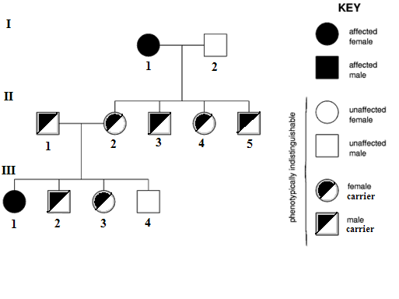

Marfan syndrome - A hereditary disorder of connective tissue, resulting in abnormally long and thin digits and also frequently in optical and cardiovascular defects.

- Pedigree Chart =
  - A chart that can help trace the __________________and ___________________ in a family to determine whether people carry recessive alleles.
    - It can be used to trace traits / disorders within a family.

- Pedigree Practice Problems:
  - Tracing Sex-linked Genes: Pedigree for Colorblindness

- Colorblindness is a _____ - linked _________________________ trait.
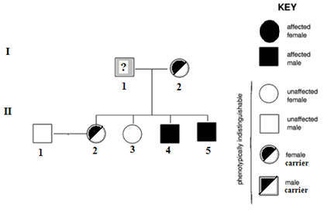
- What is the genotype of I-1: _________________________________
- What is the phenotype of I-1:_________________________________
- What is the phenotype of II-4: ________________________________

What are Autosomal Recessive disorders?
Mutations (or changes in the DNA that codes for a gene) have occurred over time in different parts of the world. Anyone can carry virtually any type of recessive gene; however, there may be certain ethnic groups more likely to carry certain recessive genes, because of where the mutation originated. For example, the gene which causes Cystic Fibrosis is found most commonly in Caucasians, and even more commonly in Caucasians of European descent. However, Cystic Fibrosis can also occur in others, but it is not as common.

Cystic Fibrosis:
Cystic Fibrosis (CF) is an inherited disease that causes thick, sticky mucus to form in the lungs, pancreas and other organs. In the lungs, this mucus blocks the airways, causing lung damage and making it hard to breathe. In the pancreas, it clogs the pathways leading to the digestive system, interfering with proper digestion.
Cystic Fibrosis is an autosomal recessive disorder. The gene for CF is located on Chromosome 7.
People with CF have a shorter-than-normal life expectancy. The good news is that as treatments for CF improve, the life expectancy for people with the disease is rising. Fifty years ago, children with CF often died before attending elementary school. Today many people with the disease live into their 30s, 40s and beyond. Getting early treatment for CF can improve your quality of life and your lifespan.

Sickle Cell Anemia (SC)
Sickle cell anemia is an autosomal recessive disorder that is caused by a genetic defect on chromosome 11.
Sickle cell anemia is one of the most common, inherited single gene disorders in African-Americans. About one in 600 African-American babies is born with SC, and about one in 12 African-American people carries the gene for SC. Sickle cell disease involves the red blood cells, or hemoglobin, and their ability to carry oxygen. Normal hemoglobin cells are smooth, round, and flexible, like the letter "O", so they can move through the vessels in our bodies easily. Sickle cell hemoglobin cells are stiff and sticky, and form into the shape of a sickle, or the letter "C" when they lose their oxygen. These sickle cells tend to cluster together and cannot easily move through the blood vessels. The cluster causes a blockage and stops the movement of healthy, normal oxygen carrying blood. This blockage is what causes the painful and damaging complications of sickle cell disease.
Sickle cells only live for about 15 days, whereas normal hemoglobin cells can live up to 120 days. Also, sickle cells risk being destroyed by the spleen because of their shape and stiffness. The spleen is an organ that helps filter the blood of infections. Sickled cells get "stuck" in this filter and die. Due to the decreased number of hemoglobin cells circulating in the body, a person with sickle cell is chronically anemic. The spleen also suffers damage from the sickled cells blocking healthy oxygen carrying cells. After repeated blockages, the spleen is very small and does not work properly. Without a functioning spleen, these individuals are more at risk for infections. Infants and young children are at risk for life-threatening infections. Treatment includes prompt emergency care for fevers and infections, appropriate vaccinations, penicillin, and management of anemia

Dominant Allele Disorders:
Autosomal dominant is one of several ways that a trait or disorder can be passed down through families.
If a disease is autosomal dominant, it means you only need to get the abnormal gene from one parent in order for you to inherit the disease.

Information
Dominant inheritance means an abnormal gene from one parent is capable of causing disease, even though the matching gene from the other parent is normal. The abnormal gene "dominates" the pair of genes. If just one parent has a dominant gene defect, each child has a 50% chance of inheriting the disorder.
For example, if four children are born to a couple and one parent has an abnormal gene for a dominant disease, statistically two children will inherit the abnormal gene and two children will not. Children who do not inherit the abnormal gene will not develop or pass on the disease. If someone has an abnormal gene that is inherited in an autosomal dominant manner, then the parents should also be tested for the abnormal gene.
Huntington's disease is a disorder passed down through families in which nerve cells in certain parts of the brain waste away, or degenerate. Huntington's disease is caused by a genetic defect on chromosome 4.
There are two forms of Huntington's disease.
- The most common is adult-onset Huntington's disease. Persons with this form usually develop symptoms in their mid 30s and 40s.
- An early-onset form of Huntington's disease accounts for a small number of cases and begins in childhood or adolescence.
If one of your parents has Huntington's disease, you have a 50% chance of getting the gene for the disease. If you get the gene from your parents, you will develop the disease at some point in your life, and can pass it onto your children. If you do not get the gene from your parents, you cannot pass the gene onto your children.

Symptoms

Behavior changes may occur before movement problems, and can include:

- Behavioral disturbances
- Hallucinations
- Irritability
- Moodiness
- Restlessness or fidgeting
- Paranoia
- Psychosis
Abnormal and unusual movements include:
- Facial movements, including grimaces. Slow uncontrolled movements
- Quick, sudden, sometimes wild jerking movements of the arms, legs, face, and other body parts
- Unsteady gait
Pedigree Practice:
For Questions 1-9, use the pedigree chart shown below. Some of the labels may be used more than once.
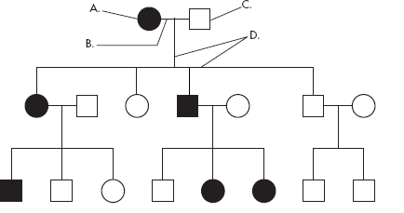

- A male = ________
- A female = ________
- A marriage = ________

- A person who expresses the trait = _______
- A person who does not express the trait = _______
- A connection between parents and
Offspring = ________
- How many generations are shown on this chart? = ________
- Assuming the chart above is tracing the dominant trait of "White Forelock (F)" through the family. F is a tuft of white hair on the forehead.
8. What is the most likely genotype of individual “A”? (FF, Ff or ff?) = ________
9. What is the most likely genotype of individual “C”? (FF, Ff or ff?) = ________

10. For a certain animal, black fur color is dominant over brown fur color. The pedigree below shows a cross between to individuals that have black fur.
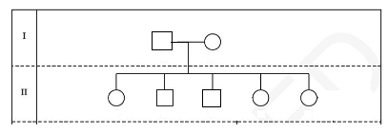
Which of the following must be true?
- Both parents are homozygous for the black-fur trait.
- Both parents are heterozygous for the black-fur trait.
- The offspring with brown fur has a mutant gene for fur color.
- One parent is heterozygous and the other is homozygous for fur color.

- The diagram below shows a pedigree for a genetic recessive disorder
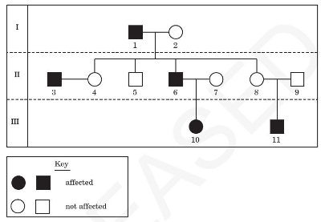
What is the genotype of individual 6?
- X^{H} X^{H}
- X^{H} X^{h}
- X^{H} Y
- X^{h} Y

- If this pedigree below shows an autosomal recessive disorder, what MUST the genotype of individual II-3 be?
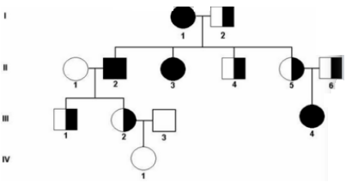
  - H H
  - H h
  - h h
  - None of the above.

