Genetics #1: Meiosis and Mendel
For additional support and information, read and reference
Chapter 12 in your Biology “Bee” Book.

- Section 1 – Chromosomes and Meiosis
  - Somatic Cells vs Germ cells
      - Somatic =

      - Germ =

          - Female =
          - Male =

    - Chromosome =
      - Each species has a characteristic number.
      - Humans =

      - Each pair = Homologous pair – b/c

        - One comes from the ________________________ and one from the_________________________.

        - Code for the same type of traits

      - Autosomes vs Sex Chromosomes
        - Autosomes =

        - Sex Chromosomes =

          - X and Y
            - X and Y are not _________________________
            - When pairing
              - XX =

              - XY =
              - The Female can only donate and ___________

              - The Male can donate an X or and ___________

    - Sexual Reproduction

        - They fuse and become one cell =

    - Diploid vs Haploid
      - Body cells =

        - One from the mother and one from the father
        - Diploid cells are represented by 2n.
          - Diploid 2n…

      - Gametes =
        - Contains only

        - Represented by : (n)
          - In humans = 22 autosomes + 1 sex chromosome
          - n = 23
Section 1 Review Questions:
- Identify:
Which cell type makes up the brain? ___________________________

- Summarize:
Are homologous chromosomes identical to each other? Explain

- Apply:
Why is it important that gametes are haploid cells?
Section 2:
  - Meiosis: Nuclear division
    - 1 Diploid “Germ Cell” …..

    - Has two major parts:

      - Each of these contains 4 steps:
      - That means from start to finish there are 8 total steps.
        - Read and Study the Image on page 174 and 175

    - Homologous Chromosomes:

      - Very similar in size and appearance.
      - Carries the same genes on each.
  - One will have mom’s info.
  - The other will have dad’s info.

    - Chromatid:
      - Each half of a duplicated chromosome is called a = ___________________________
      - Sister Chromatids =

        - Not divided until ______________________________

    - Gametogenesis :

      - Sperm

Draw and Label

      - Egg

        - Polar Bodies

Section 2 Review Questions:
- Contrast:
What is the major difference between metaphase I and metaphase II?

- Infer:
Explain why Mendel’s choice of either-or characteristics aided his research?

Section 3:
- Traits:

  - Examples:
- Genetics:

  - Father of Genetics: ______________________________________

    - He worked with ______________________________ because they reproduce quickly and he could ___________________________________________________________.

    - Each plant contains both __________________ and _________________reproductive organs.
    - This means that in nature, the peas would typically self-pollinate. (plant mates with itself).
    - Over time when organisms self-pollinate they can develop a_____________________________.
    - Purebred =

    - Mendel’s Three Key Choices:

- Cross =
- Mendel demonstrated that traits are inherited as____________________________.
  - They are not blended or diluted.
- Law of Segregation:
  - Organisms inherit __________________ copies of each gene, one from each parent.
  - Organisms donate only __________ copy of each gene in their gametes. Thus the two copies of each gene segregate, or separate, during gamete formation.

Section 4 - Traits, Genes and Alleles

- Gene:

  - Each gene has a specific position or __________________________ on a pair of homologous chromosomes.
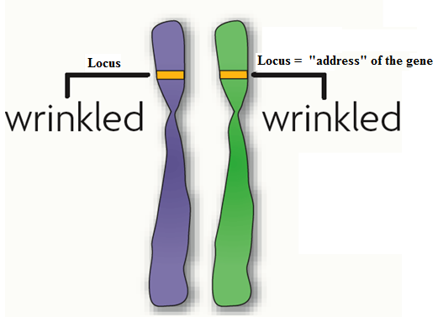
  - Allele:

    - Your cells have two alleles for each gene because……

      - Dominant:

        - If you inherit this allele it will show up.
        - Example:

      - Recessive:

        - Example

      - If the alleles are different we call them:
        - (Hetero) = different

        - Example :

      - If the alleles for the trait are the same we call them:

      - However, there are two ways that alleles can be homozygous:

  - Genome:

  - Genotype:

  - Phenotype:

    - If it is a trait that can be seen, then the phenotype is what you see!

Section 5– Traits and Probability
- Punnett Square:

  - Remember that is a cross is defined as: Mating of two organisms.
  - Visual Vocab: Draw and Label the Punnett Square that is on page 183.

  - Monohybrid Crosses:

    - Sample Problem: Let’s Cross a Purebred Tall Plant with Purebred Short plant. To help you out on this problem, think back to what the term “Purebred” tells us.

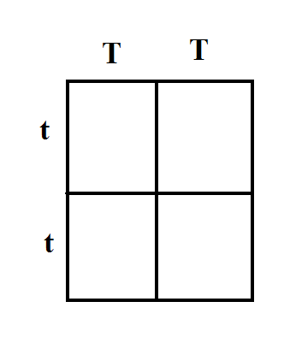
        - How many of the offspring will be Homozygous dominant? ___________

        - What is the phenotype of all of the offspring? ______________________

- Use the following information and set up and work out the Punnett Square.
  - In Mendel’s Pea plants
    - Purple flowers are dominant. (F)
    - White flowers are recessive. (f)
    - What would the outcome be if you crossed to plants that were both heterozygous for flower color?

- Testcross:

- Dihybrid Crosses:

  - Example Worksheets = Use the practice Dihybrid Cross worksheets to help you better understand this concept.

- Law of Independent Assortment:

- Probability

