Bio-Chemistry #2: Chemical Reactions - Enzymes
For additional support and information: Read Chapter 2 Lesson 4 in your Biology book

- Chemical Reactions:

  - Reactants vs Products: Draw Example

  - Bond Energy:

  - Exothermic Vs Endothermic Reactions:

    - Exothermic:
      - Chemical reaction that releases _____________ energy that it _________________.
      - If the _______________________ have a lower bond energy than the ______________________, the reaction is exothermic.

        - Exothermic Example:
          - ______________________________ releases not only useable energy for your cells but also heat that keeps your body warm.

    - Endothermic:
      - Chemical reaction that absorbs ______________ energy than it________________.
      - If products have a higher bond energy than the reactants, the reaction is Endothermic.
        - Endothermic Example:
          - During Photosynthesis, plants absorb energy from sunlight and use energy to make simple sugars and complex carbohydrates.
          - Thus……..

--------------------------------------------------------------------------------------------------------------------------------------------------
- Enzymes:
  - A _______________________ is a substance that decreases the activation energy needed to start a chemical reaction. It will also increase the rate of a chemical reaction.
  - Compare the activation energies and the reaction rates in the graph below.
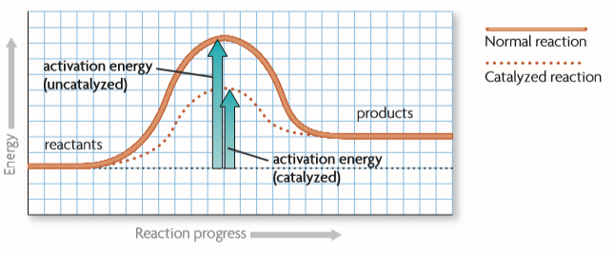

  - Under normal conditions, the reaction requires a certain amount of activation energy and it occurs at a certain rate.
  - When a catalyst is present…

