Cells #1: Cell Theory, Cell Organelles and Cell Membrane
For additional support and information: Read and reference Chapter 8 in your Biology Book

Section 1 = Cell Theory
- Cells:
- _______________________: Enable scientist to view and study cells
  - Early studies led to the development of the cell the cell theory:
    - Robert Hooke:

      - Looking at a piece of a ________________(tree bark).
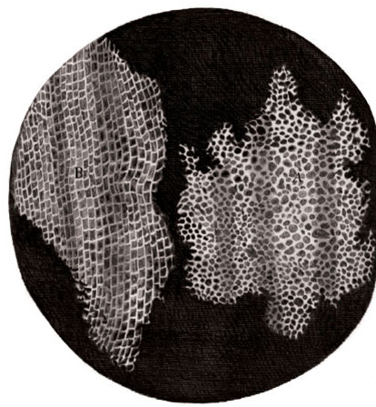
      - Used a __________________________microscope
      - Though its crude lenses severely limited the amount of detail that he could see.
      - Saw the spaces that cells once occupied = ________________________
    - Anton van Leeuwenhoek: (A Dutch tradesman that was born the son of a basket-maker. He was trained as a fabric merchant. He was accustomed to using magnifying lenses to examine threads. To make his job easier he worked on making his lenses stronger. Eventually he succeeded and one of his single lenses was actually stronger than Hooke’s compound light microscope.
      - In 1674 Leeuwenhoek became the 1st to ___________________________
      - Saw numerous single celled organisms swimming in________________________.
***** Due to these two discoveries, scientists began to ask: Are all living things made of cells? And where do cells come from?
  - Cell Theory:
    - Mostly developed by three German scientists

        - Has 3 major parts.

    - Your body contains trillions of cells of many different shapes and sizes.
      - In general, cells…..
        - Tend to be ______________________ in size and have similar building blocks.
        - Enclosed by a _________________that controls what _____________________________the cell.
        - Contain cytoplasm:

          - In SOME cells the cytoplasm contains __________________________.
            - Organ like structures that are specialized to do certain jobs.

      - We can put cells in two different groups: Prokaryotic and Eukaryotic
        - Prokaryotic Cells:

        - Eukaryotic Cells:

            - Nucleus =
          - Can be….
Summarize:
- Explain the three major principles of cell theory in your own words.

- What characteristics are shared by most cells?

----------------------------------------------------------------------------------------------------
Section 2 - Organelles
  - Cells have an internal structure:
    - Cells are highly _______________________ structures.
      - Organelles and molecules are anchored to specific sites, which vary by types.
      - And it _________________________keeps all of the cells content from oozing out.
    - Framework of the cell:
      - Eukaryotes contain a cytoskeleton:
        - Network of __________________________ that constantly change to meet the need of the cell.
        - Protein _____________________ that crisscross the entire cell.
          - 3 main types of protein fibers:

        - Cytoplasm also helps when it comes to cell structure.
          - In eukaryotes, it fills the space between the nucleus and the cell membrane. The fluid portion is called ______________________ and consists mostly of _______________________.
            - This is why ______________________ is necessary for maintaining cell structure.
            - The water also acts as a ____________________ for the many chemical reactions that occur in cytoplasm.
    - Plant cells vs. Animal Cells
      - Both use many of the same type of organelles that carry out basic functions.
      - But both cell types also have organelles that are ______________________ to their _______________________.
- Several organelles are involved in making and processing proteins:
  - Main job of the cell:
    - Proteins are made from __________ types of __________________________
      - Proteins carry out many ________________________ and it is important to make them correctly.
  - Organelles of the Cell
    - Nucleus: The Brain of the cell
      - Stores _________________________________called DNA.
      - DNA contains the instructions for making ____________________________
      - The DNA in the nucleus is enclosed in a double membrane called the nuclear membrane.
      - The nucleus also contains the ____________________________:
        - This is where the __________________________ are assembled.
    - Endoplasmic Reticulum (The ER)
      - Fills a large part of the cytoplasm
      - Site of __________________________________________
      - An interconnected network of thin folded membranes.
        - Interior portion of this maze = _____________________________
        - Production of proteins and lipids occur both on the surface of the ER and in the Lumen
        - Highly folded =

        - Some parts contain ribosomes:
          - Actually made of proteins and RNA. After they are made in the nucleolus, they pass through the nuclear pores into the cytoplasm where more of the protein synthesis occurs.
        - Rough ER = __________________________________
          - Function = Makes ________________________and sends them to the lumen
        - Smooth ER = ________________________________
          - Function =
          - Responsible for breaking down drugs and alcohol
    - Golgi Apparatus: The Post Office
      - Consists of Layered stacks of membrane-enclosed spaces that:

        - Proteins move from ER to the Golgi.
      - It’s the Postal Service of the Cell:
        - Where does it send the proteins???
          - Some…..

- Vesicles:
  - The _______________________________
    - Small membrane-bound sacs that ________________________________ from the rest of the cytoplasm.
    - After a protein has been made, part of the ER pinches off to form a vesicle surrounding the protein.
      - This allows for the protein to be safely ______________________ to the Golgi apparatus.
        - Once a protein reaches the Golgi apparatus, it is then……
- Mitochondria:

  - It supplies cellular _______________________ to the cell.
  - _______________________ organelle.
  - Contains its own ribosomes and DNA.
    - These are thought to have once been free-living prokaryotes that were taken in by larger cells.
    - If so…. This must have been a relationship that helped both organisms survive.
- Vacuole:

    - Stores water, food molecules, inorganic ions and enzymes
  - In Animal Cells…
    - __________________ vacuoles (if any).
  - Plant Cells
    - ___________________ vacuoles

- Lysosomes:
  - The ___________________________
    - Membrane bound organelle that contains_________________________________.
      - What is an enzyme???
      - A _______________________________ that causes chemical reactions to start, stop, speed up, or slow down.
        - Hmmmmmmm…….
          - If enzymes are proteins, where do you think they are made?

    - They…..

      - Think about this….
        - If lysosomes can destroy worn out cells parts, what prevents them from destroying functioning cell parts?
          - Lysosomes are surrounded by a ___________________ that prevents the___________________________________________.

- Centrioles:

    - Microtubules……… what other cell part contains these?
      - _________________________________
  - The Centrioles help form ______________________ and ________________________.
    - Both of these structures aid in ____________________________.

Cilia: Flagella:

- Cell Wall:
  - Found only in __________________________________________________.
    - It is a ______________________________________________that gives _____________________, _____________________, and _______________________ to the cell.
    - In plants, the cell wall is made up of_________________________, a polysaccharide.
      - What is a polysaccharide?
        - ________________________________________

- Chloroplasts:

  - Chlorophyll is a _____________________________that is found on the inside of the chloroplasts.
    - Chlorophyll is responsible for _________________________________.

3.2 Questions:
1. What problems might a cell experience if it had no cytoskeleton?

2. How are the nucleus and a vesicle similar and different in structure and function?

3. In what ways are lysosomes, vesicles and the central vacuole similar?

4. Would it be accurate to say that a chloroplast makes energy for a plant cell? Explain your answer.

Section 3 - Cell Membrane

- Cell Membrane = AKA ___________________________________

  - Controls what ________________________ and _______________________ the cell.

  - 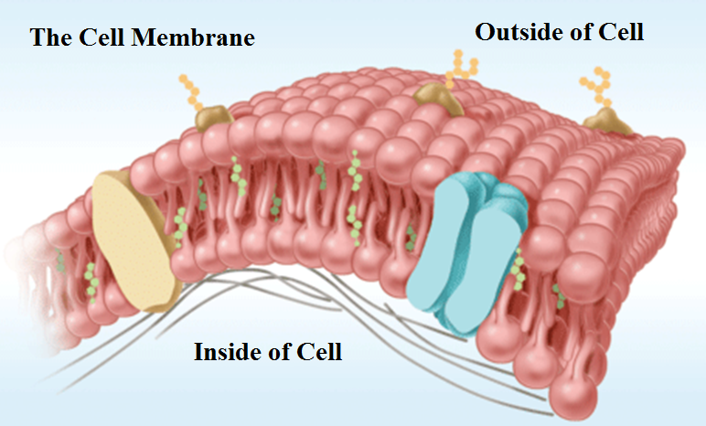

  - It has a double layer of phospholipids, this is why they call it a : __________________________

    - Phospholipid:

      - Polar Vs Non-Polar:
        - Heads =

        - Tails =
- Fluid Mosaic Model:
  - Describes the arrangement of the molecules that make up a cell membrane.
    - It is = _____________________________________
      - Phospholipids can _________________ past each other in a “______________” motion.

- Other Molecules of the Cell Membrane:
  - Cholesterol =

  - Proteins =

  - Carbohydrates =

- The Cell membrane is…….

- Some things can cross but not all.

  - Diagram of Cell Membrane:

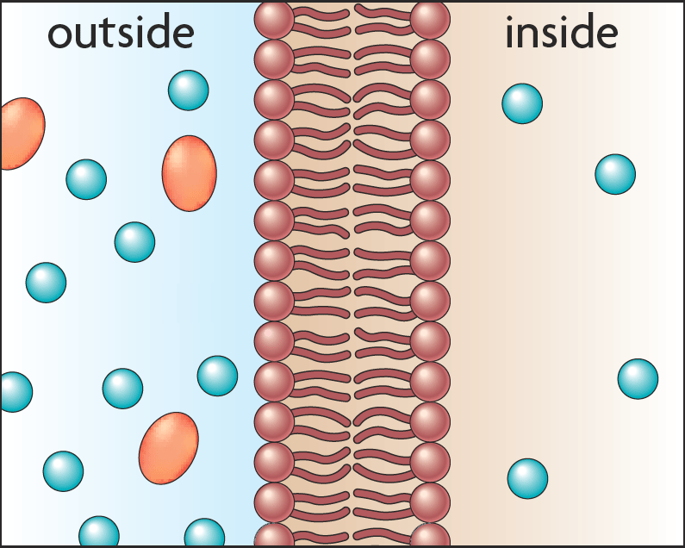

- Selective Permeability = Semi- Permeable
  - Allows the cell to maintain ___________________________
  - Allows some but not all molecules to pass
    - Molecules cross in several ways
      - Some use energy = __________________________________
      - Others do not = ___________________________________

  - Being Semi-permeable
- Allows the cell to…..__________________________________
  - Must be maintained because many ______________________________can occur ______________________________________________________.

- Chemical signals are transmitted across the cell membrane.
  - Receptor

Chapter 3.3 Questions:
- Compare and describe a semipermeable membrane with something that you are already familiar with:

Chapter 3.4 – 3.5 Power Notes - Cell Structure and Function
Chapter 3.4 Diffusion and Osmosis

- ___________________________ = The movement of molecules across a cell membrane without energy input from the cell.
  - Examples of Passive Transport:

  - Diffusion =

    - Air Freshener Demo.

  - Osmosis = A special type of diffusion.

    - Particles will move from areas of ___________________________ to areas of ____________________________
  - Diffusion and Osmosis:
    - Both work due to a concentration gradient.
    - Concentration gradient =

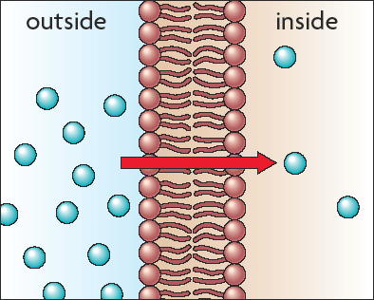
  - Facilitated Diffusion:
    - Is also a special type of _________________________.
    - It is the diffusion of molecules cross a cell membrane with the use of ___________________________.
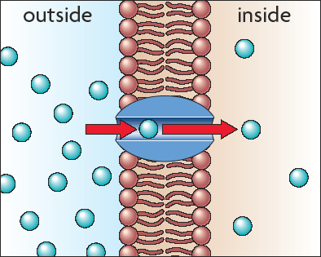

- Types of solutions that cause Osmosis to occur:
  - A solution may be described as isotonic, hypertonic, or hypotonic relative to another solution.

  - Isotonic Solution:

    - Water and particles move ____________ the cell at the SAME rate as they move out of the cell.
    - If equal parts of water are entering and leaving the cell, the cell stays_______________
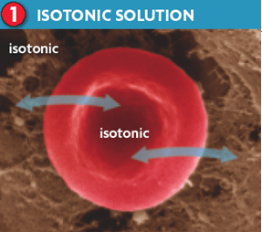
  - Hypertonic Solution:
    - A solution that has a higher concentration of dissolved particles than a cell.
    - This means that water from inside the cell ___________________________of the cell in order to try to___________________________________.
    - If water is rushing out of the cell, the cell will start to _______________________.
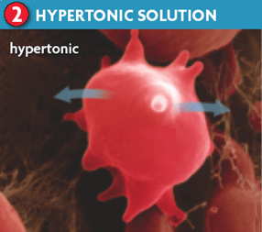
  - Hypotonic Solution:
    - A solution that has a…..

    - This means that water from the outside of the cell will rush __________________the cell in an attempt to ______________________ the dissolved particles.
    - If water is rushing into the cell, what will happen to the cell?? ___________________________
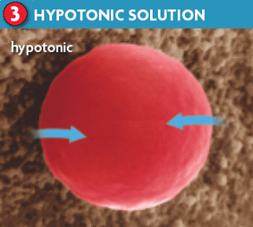
Review Questions:
- What will happen to a houseplant of you water it with salt water (a hypertonic solution)?
____________________________________________________________________________________
____________________________________________________________________________________
- Explain why transport proteins are needed in the cell membrane.
____________________________________________________________________________________
____________________________________________________________________________________

Chapter 3 Lesson 5:
- Active Transport
  - __________________________.
  - Cells can use energy to move molecules from an area of lower concentration to an area of higher concentration. (Moving against the flow!)
  - Examples of Active Transport
    - __________________________
    - __________________________
    - __________________________

    - Endocytosis:
      - The prefix “endo-” means “_______”
      - The cell membrane starts to fold in, forming a pocket around a substance. The pocket breaks off inside the cell, making a ______________________?
        - Hmmm…. What is a vesicle?
          - Small sacs that carry proteins and other molecules to where they are needed.
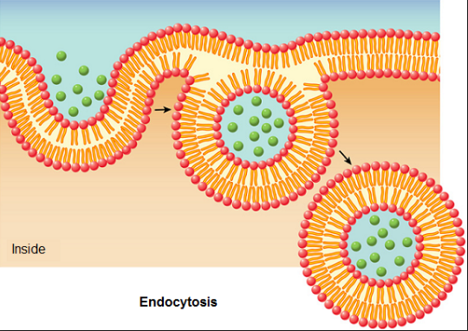
      - Phagocytosis:
        - A special type of ___________________________in which the cell membrane grows out to surround large particles.
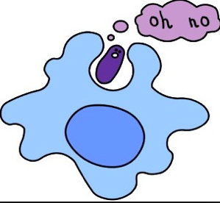
      - Exocytosis:
        - ______________________________________________________
        - The prefix “exo-” means “_______”
        - A vesicle surrounds materials that need to be _____________________.
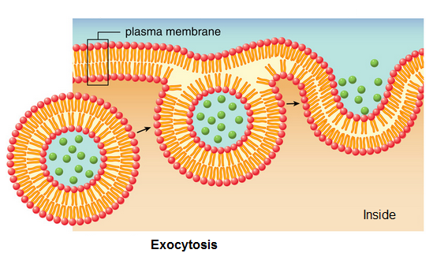
Review Questions:
- In what ways are active transport proteins similar to enzymes?
____________________________________________________________________________________
____________________________________________________________________________________

- What might happen if a vesicles in your neurons were suddenly unable to fuse with the cell membrane?
____________________________________________________________________________________
____________________________________________________________________________________

